1. Data Cleaning
   1. Raw data snapshot

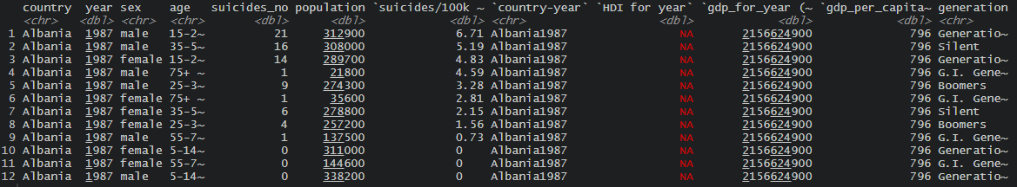

Cleaned data snapshot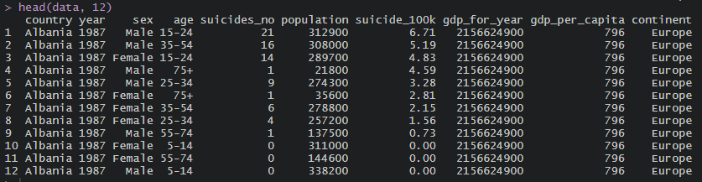

* + - Removed countries with <3 years of data
    - Removed year 2016
    - Removed certain columns
    - Cleaned data value
    - Get respective continent from countrycode package
    - …

1. Statistics for linear model
   1. Outliers Removal  
      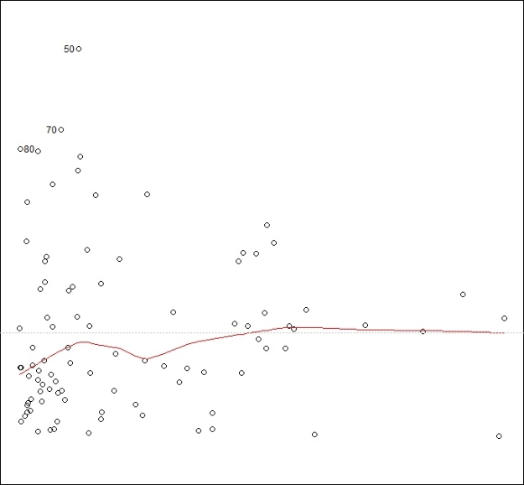

Homoscedasticity likely to be violated.

* 1. Influential Points Removal (Cook’s Distance < 4/n)
  2. Linear regression output

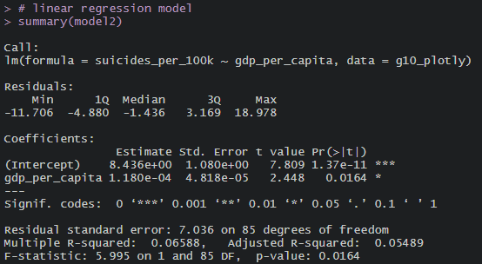

* 1. Normality assumption violated

